CloudKon clone with Amazon EC2, S3, SQS, and DynamoDB

Introduction :
This assignment is implemented in order to experiment with:
● Amazon Web Services:
- EC2 cloud
- S3
- DynamoDB
● Distributed load balancing

For this, a distributed task execution framework is implemented on Amazon EC2 using the SQS. The CloudKon – Task Execution Framework was studied for the better understanding of context. We have used EC2 for running our framework. This framework is separated into two components as:
1. Client
2. Workers

SQS service along with Amazon DynamoDB will be used to handle the queue of requests to load balance across multiple workers. We have used Programming language Python for the internal logic. Below we will see each of these component and its working in detail:

1. SQS service :
Amazon offers an SQS (Simple Queue Service) service that handles the queue of requests to load balance across multiple workers. SQS gives us a faster, scalable, reliable, fully managed message queuing service. SQS makes it easy and cost-effective for us when it comes to decoupling the cloud application components. SQS can transmit data of any size, at any level of throughput, with zero loss of messages or necessity of other services being always running/up.

However, SQS does not guarantee uniqueness. i.e. it is possible that a task will be assigned to workers twice by SQS. Hence one task can be duplicated by more than a worker. In our assignment we will attempt to overcome this flaw in SQS by using another service of Amazon i.e. DynamoDB.

2. Amazon DynamoDB:
Amazon DynamoDB is a service provided by Amazon that offers faster and flexible NoSQL databases for all applications with the requirement of consistent, single-digit millisecond latency at any given scale. DynamoDB is a fully managed cloud database with support given for both models : document and key-value store. It provides amazing features like: flexible data model, reliable performance that makes it a proper fit for mobile, web, gaming, sort of applications.

3. The Client:
We have implemented a client in the file: Client.py
The client will be responsible for submitting the tasks to SQS which will further be accessed by workers. The client is different for local workers and remote workers.

A. Local Client:
The local Client is using following interface:
client –s LOCAL -t N-w <WORKLOAD_FILE>
where, LOCAL : denotes that it is the local worker version
WORKLOAD_FILE : local file storing all tasks that need to be submitted to the workers
N : number of threads in the thread pool (number of concurrent tasks to execute)

B. Remote Client:
The remote Client is using following interface:
client –s QNAME -w <WORKLOAD_FILE>
where, QNAME : name of the SQS queue and DynamoDB instance
WORKLOAD_FILE : local file storing the tasks that need to be submitted to the SQS

4. The Workers:
Workers will retrieve tasks from SQS and execute them. Our framework supports only sleep tasks, and therefore we can run a large number of sleep tasks on the same resource where the client runs. We have implemented a configurable size pool of threads that will process tasks from the submit queue, and when complete will put results on the result queue. The pool of threads handles only the sleep functionality, of a specified length in milliseconds.
Workers are different
When the sleep task is completed, a success value 0 will be returned. In case there is a failure (e.g. an exception, out of memory, etc), a failure 1 will be returned. Note that the communication between the client and the workers is via the in-memory queue, and there is no need for any network communication or Amazon SQS at this point

Experiments:
We are conducting 2 types of experiments:
1. Local workers
2. Remote workers

1. Local workers
There are 5*4=20 experiments in local workers. We are varying the workload from100k sleep 0 tasks, 1000 sleep 10ms tasks, 100 sleep 1000ms tasks to 10 sleep 10000ms tasks. At the same time for each workload we are varying no. of threads from 1, 2, 4, 8 to 16. Below are the observations after running these experiments one by one:

A. sleep 0 100k tasks

Observations:

Threads | 1 | 2 | 4 | 8 | 16
Time in ms | 553.85 | 454.77 | 437.88 | 415.91 | 415.55
Throughput | 180.5543017 | 219.8913737 | 228.3730702 | 240.4366329 | 240.6449284

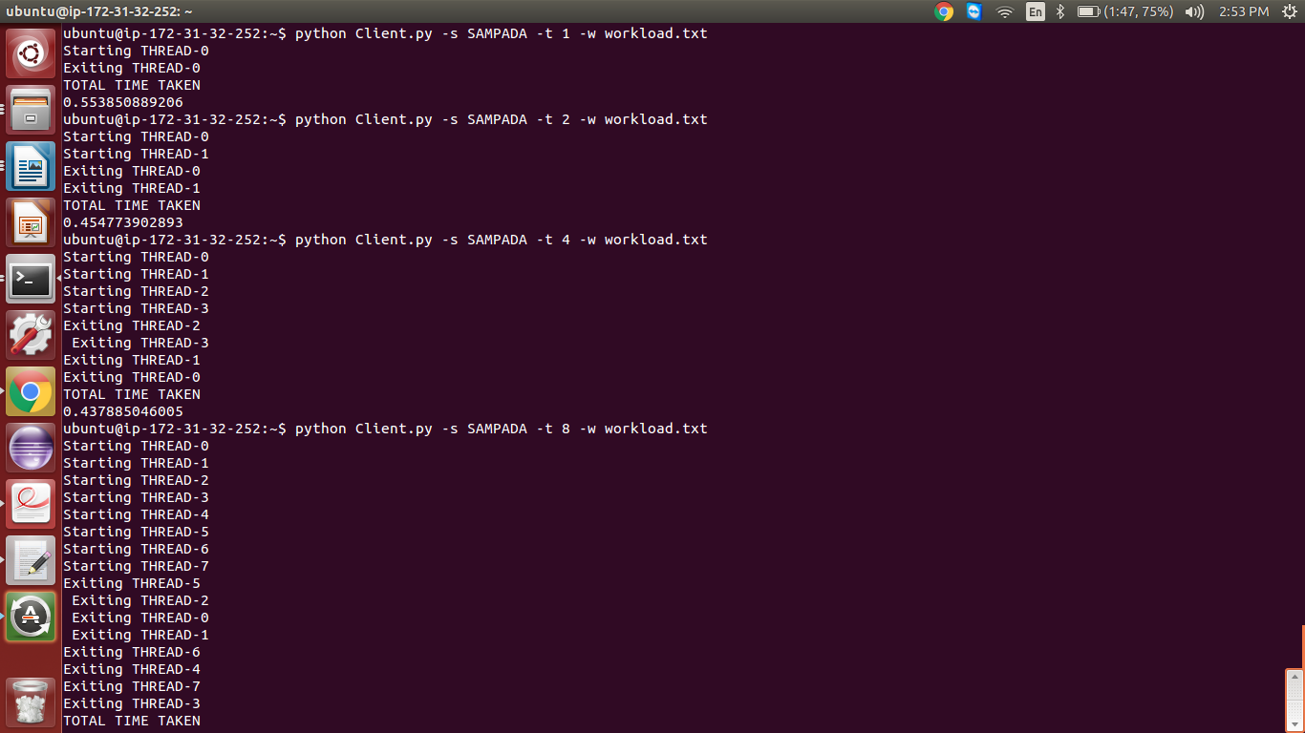

10 ms 1000 tasks

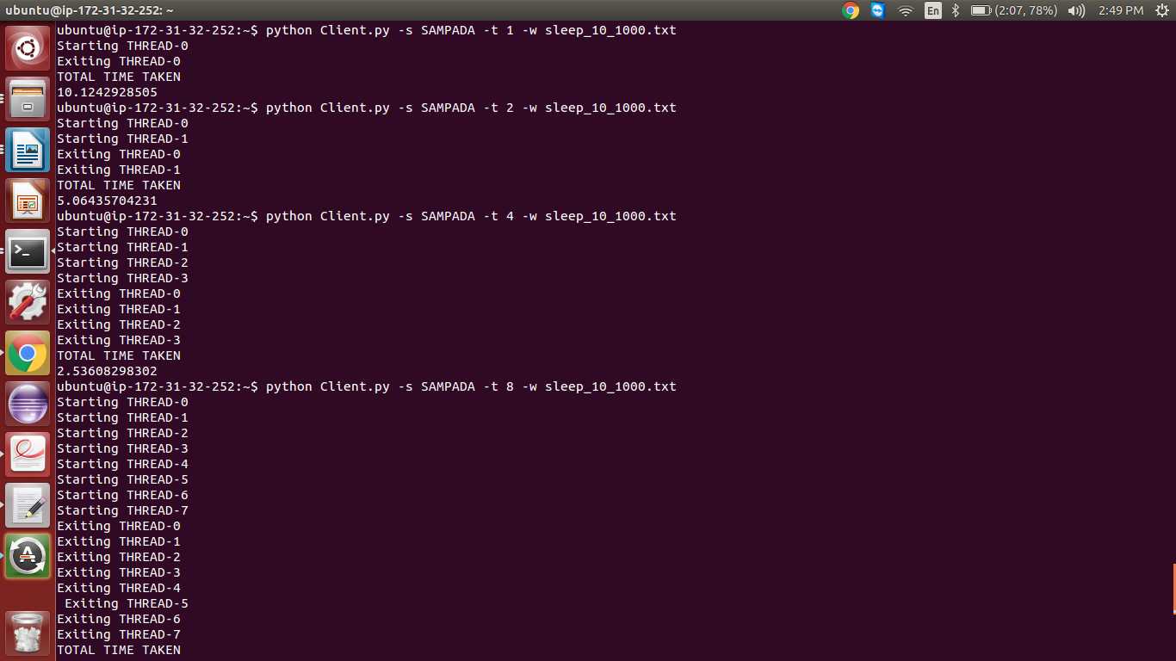
Observations:

Threads | 1 | 2 | 4 | 8 | 16
Time in ms | 10124.29 | 5064.35 | 2536.08 | 1270.84 | 638.73
Throughput | 0.09877235836 | 0.1974587064 | 0.3943093278 | 0.786881118 | 1.565606751

1000ms 100 tasks

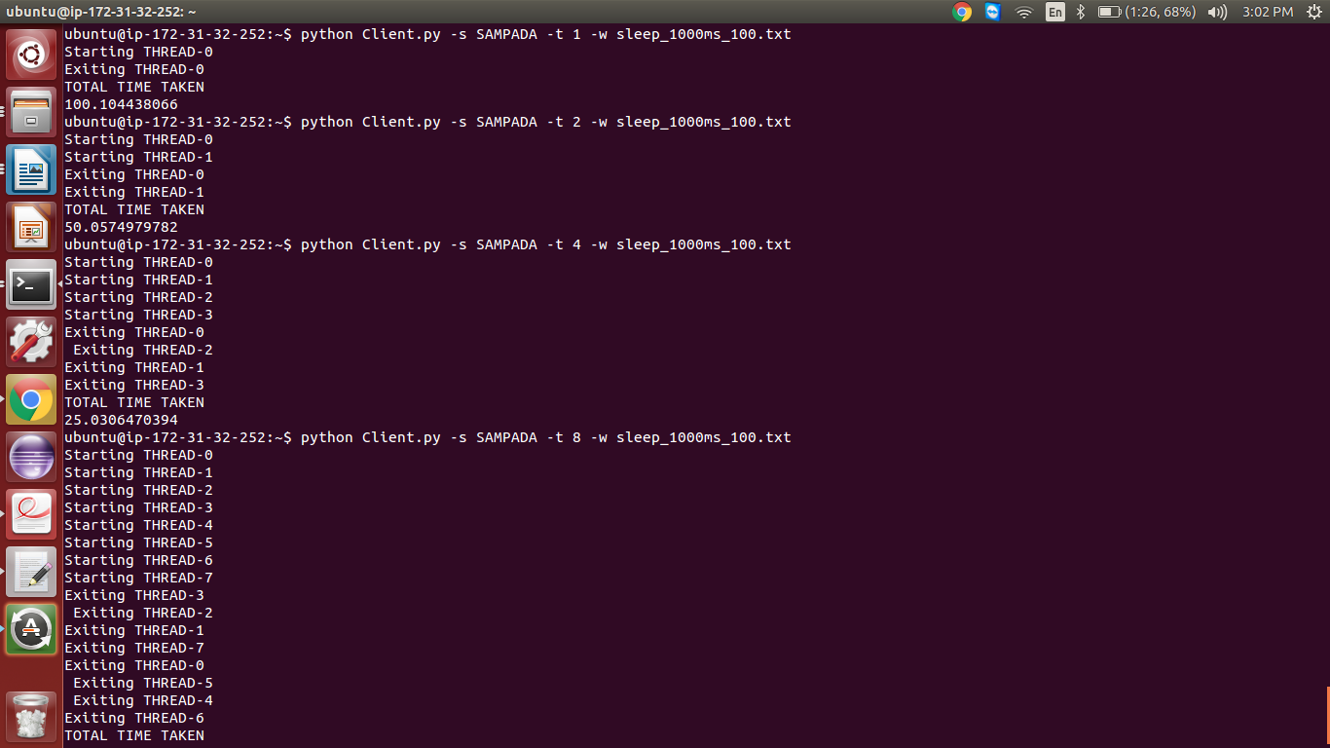

Observations:

Threads | 1 | 2 | 4 | 8 | 16
Time in ms | 100104.43 | 50057.49 | 25030.64 | 13014.4 | 7008.04
Throughput | 0.0009989567894 | 0.001997703041 | 0.003995103601 | 0.00768379641 | 0.01426932495

10000ms 10 tasks
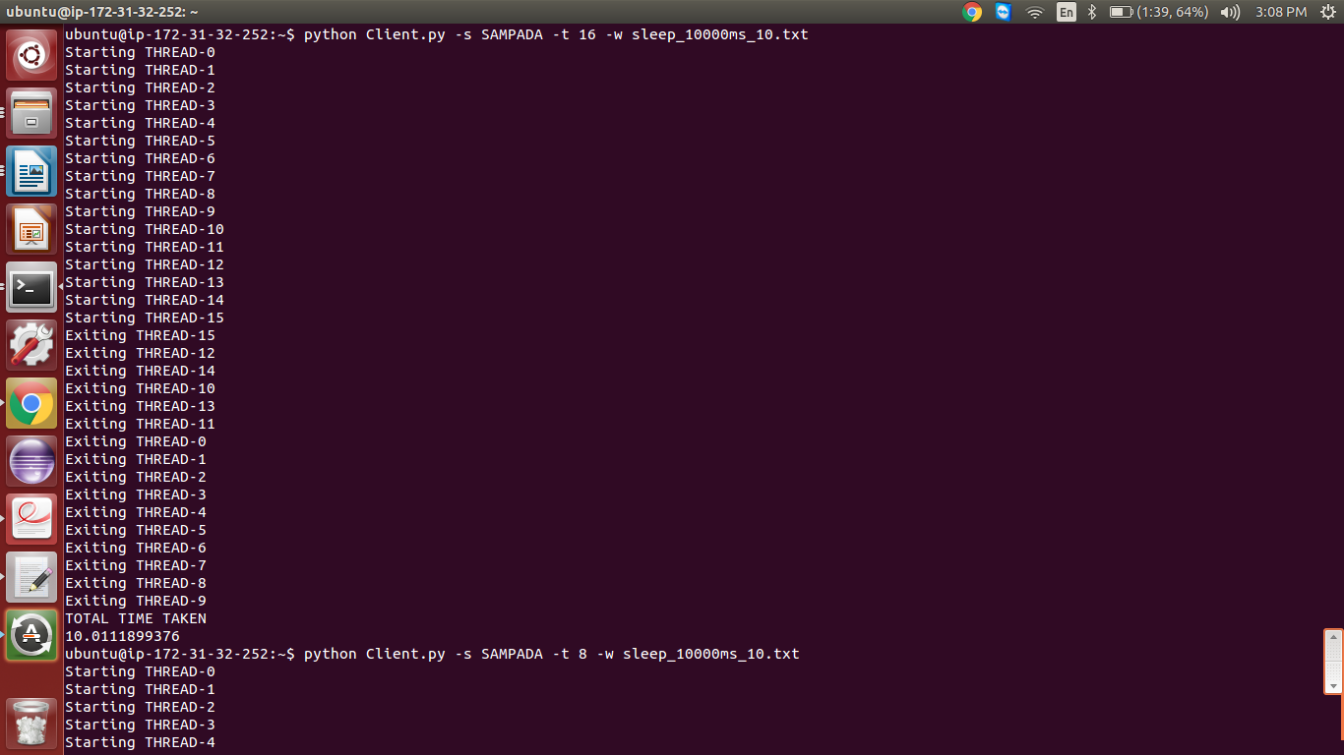

Observations:

Threads | 1 | 2 | 4 | 8 | 16
Time in ms | 100089.37 | 50043.43 | 30025.46 | 20020.47 | 10011.18
Throughput | 0.0000999107098 | 0.0001998264308 | 0.0003330506843 | 0.0004994887732 | 0.0009988832485

2. Remote Workers
There are 5*4=20 experiments in local workers. We are varying the workload from10k sleep 0 tasks, 1000 sleep 10ms tasks, 100 sleep 1000ms tasks to 10 sleep 10000ms tasks. We are varying no. of workers from 1, 2, 4, 8 to 16. We will keep no. of threads same for all i.e. 1 for fair calculations. Below are the observations after running these experiments one by one:

A. sleep 0 10k tasks

Request queue:

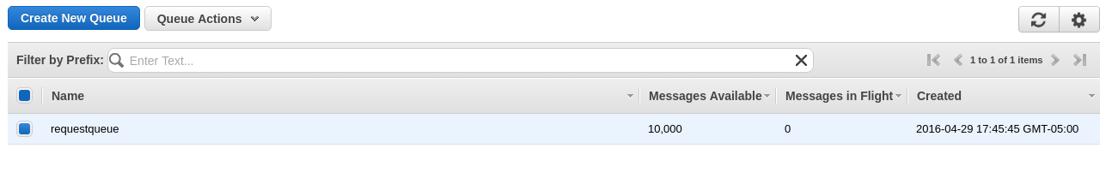

Throughput graphs:
sleep 0 100k times:

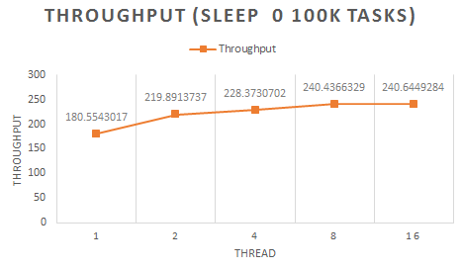

sleep 10ms 1000 tasks:

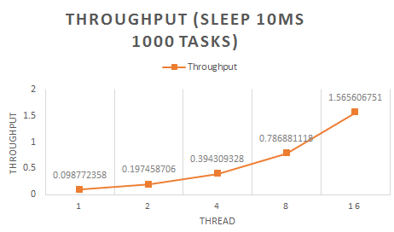

sleep 1000ms 100 times:

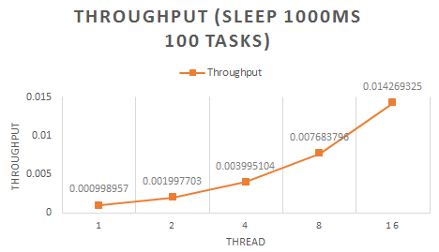

sleep 10000ms 10 times:

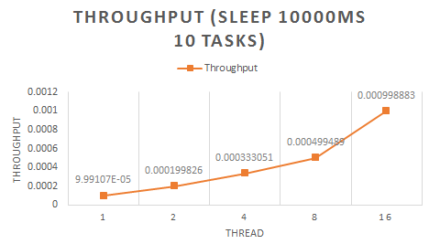

Analysis:
- As we can clearly see from above graphs, throughput increases as the number of threads are increased
- This is because the queue is in memory.
- Tasks are not performing any I/O or heavy memory tasks
- There is no waiting between threads for any resources.
- Thus the throughput is high with number of threads increased

Efficiency :

sleep 10ms 1000 times:

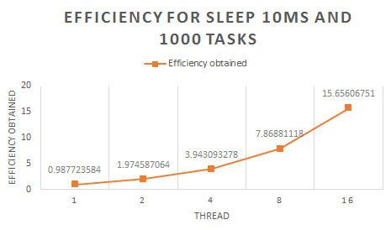

sleep 1000ms 100 times:

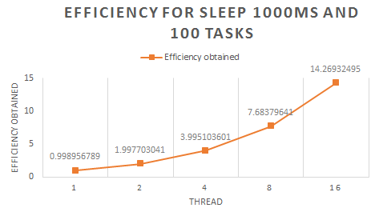

sleep 10000ms 10 times:

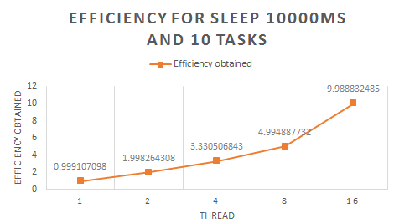

Observations:
As clearly stated in graphs, the no of workers add up the efficiency.
The increase with workload decreases the curve of efficiency
i.e. as the workload increases, the efficiency gain by workers is decreased.

2. Remote workers
Client nodes:
sleep 0 10k tasks per worker:

Workers | 1 | 2 | 4 | 8 | 16
Time in ms | 448965.265479 | 476426.454682 | 496327.512347 | 504982.204652 | 512849.348568
Throughput | 44.89652655 | 23.82132273 | 12.40818781 | 6.312277558 | 3.205308429

Throughput achieved:

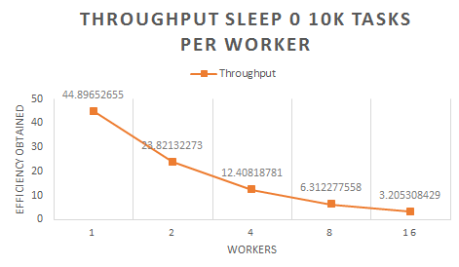

Observations:
As the graph clearly shows, throughput is decreased as the number of workers increased.
This is due to proportionate increase in the workload.
As the number of tasks increased the delay in the network also increased.
This hampered the performance drastically.
Highest throughput was achieved with 1 worker node

Sleep 10ms 1000 tasks per worker:

Workers | 1 | 2 | 4 | 8 | 16
Time in ms | 29457.2815626 | 56945.1287550 | 86497.1254826 | 156894.235480 | 319564.238466
Ideal Efficiency | 10000 | 20000 | 40000 | 80000 | 160000
Efficiency obtained | 0.3394746382 | 0.3512152916 | 0.4624431133 | 0.5098976374 | 0.5006818058

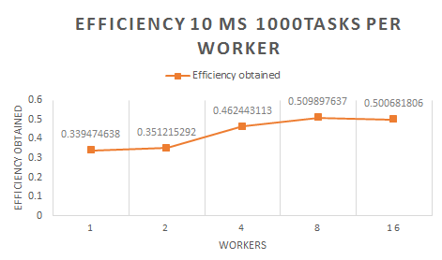

Observations:
Efficiency was decreased drastically.

Sleep 1000ms 100 tasks per worker:

Workers | 1 | 2 | 4 | 8 | 16
Time in ms | 146897.246813 | 271354.126849 | 576284.598624 | 1195026.234280 | 2268249.267140
Ideal Efficiency | 100000 | 200000 | 400000 | 800000 | 1600000
Efficiency obtained | 0.6807479525 | 0.737044254 | 0.6941014925 | 0.6694413704 | 0.7053898455

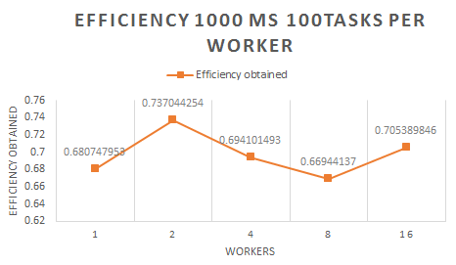

Observations:
Efficiency was decreased drastically.

Sleep 10000ms 10 tasks per worker:

Workers | 1 | 2 | 4 | 8 | 16
Time in ms | 118126.248931 | 238946.278412 | 445238.197564 | 896428.315278 | 1796245.23578
Ideal Efficiency | 100000 | 200000 | 400000 | 800000 | 1600000
Efficiency obtained | 0.846551896 | 0.8370082235 | 0.8983955155 | 0.8924305339 | 0.8907469694

Efficiency:

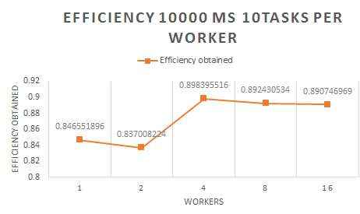

Observations:
Efficiency was decreased drastically as the worker nodes increased.

Screen shots:

Running instances:
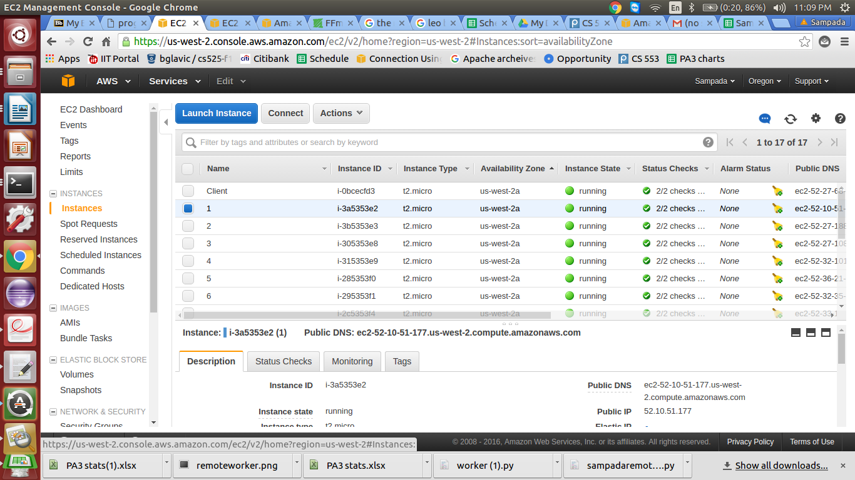

SQS Queue after running remoteClient.py :
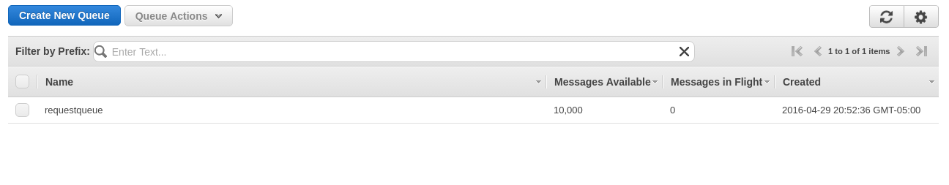
sleep 0 10000 tasks per worker: 1 worker

sleep 0 10000tasks per worker: 2 workers
sleep 0 10000tasks per worker: 4 workers
sleep 0 10000tasks per worker: 8 workers
sleep 0 10000tasks per worker: 16 workers
sleep 10ms 1000tasks per worker: 1 worker
sleep 10ms 1000tasks per worker: 2 workers
sleep 10ms 1000tasks per worker: 4 workers
sleep 10ms 1000tasks per worker: 8 workers
sleep 10ms 1000tasks per worker: 16 workers

Remote workers:
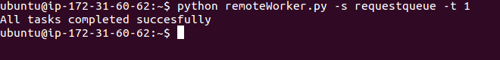
Request queue:

Worker nodes:

